BEYOND WORDS

THE COMMUNICATION OF UNIVERSAL VALUES
THROUGH
THE LANGUAGE OF ART

TEACHING UNIT 4

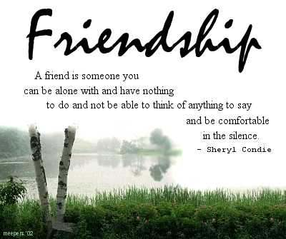

What is a friend? A single soul dwelling in two bodies. ~Aristotle



приятелство ystävyys φιλία amicizia vriendschap prietenie amistad dostluk

THE COMMUNICATION OF UNIVERSAL VALUES THROUGH PAINTING

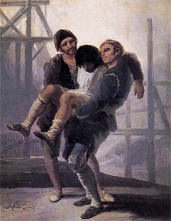

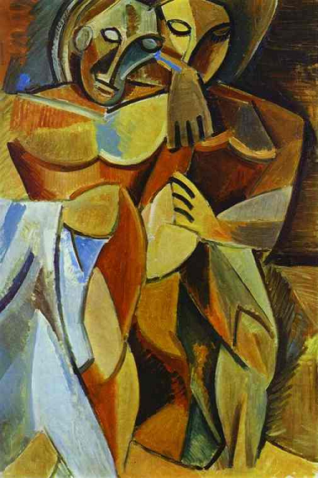

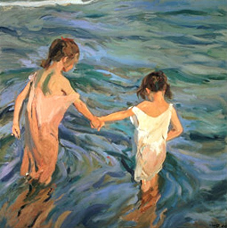

EL ALBAÑIL HERIDO

THE INJURED MASON

This picture was painted by Francisco de Goya between 1786 and 1787.

The faces of the men reflect seriousness. They also look like worried helping his injured friend.

In this painting Francisco de Goya depicts one of main features of friendship: Supporting friends when they need help.

This painting is in Museo del Prado, Madrid.

FRIENDSHIP
LA AMISTAD

Pablo Picasso
1908 The Hermitage, St. Petersburg, Russia.

Two people sitting close together: this is how the Spanish painter Pablo Picasso wanted to present the topic of friendship.

Being close together is a necessary attitude of friendship: friends need to be close to each other sharing their experiences in life.

CHILDREN IN THE SEA
NIÑAS EN EL MAR

Joaquín Sorolla y Bastida
1909 Museo Sorolla, Madrid

Sorolla depicts an elder girl afraid of water
and a younger one helping her to be confident.

Accepting friend’s help means that you rely on him.

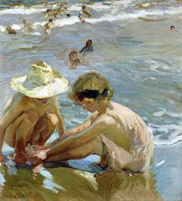

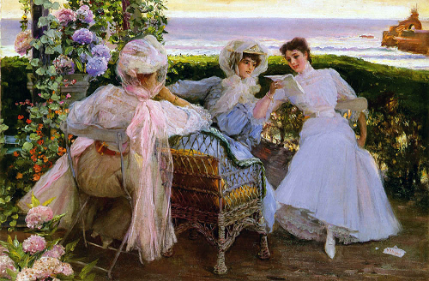

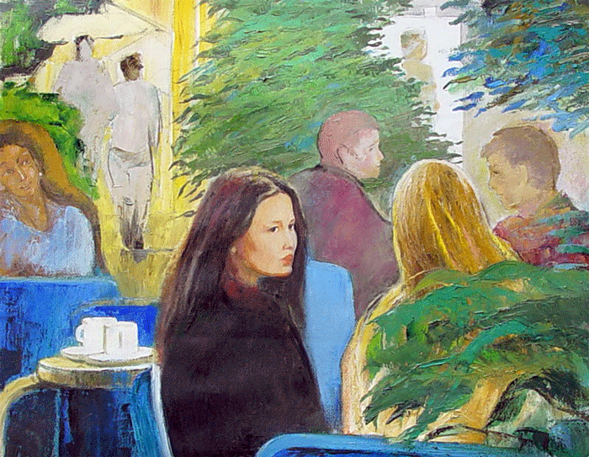
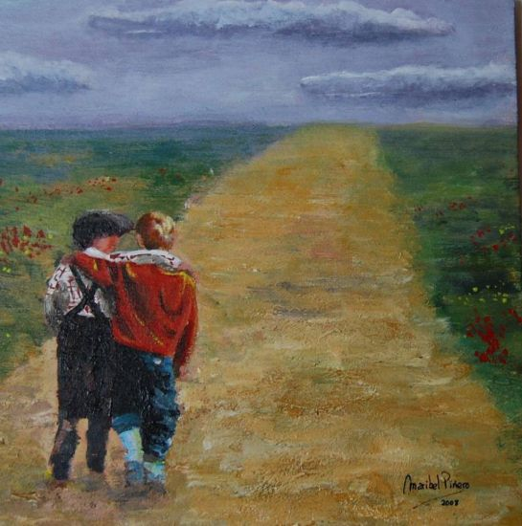

THE WOUNDED FOOT
EL PÍE HERIDO

Joaquín Sorolla y Bastida
1909 Private colection

Sharing pain is a way of strengthening friendship.

josé villegas y cordero josé villegas y cordero

THE LETTER (in Biarritz)
LA CARTA (en Biarritz)

José Villegas y Cordero
1907. Private colection

A young woman is reading a letter to her two friends.
Sharing the content of the letter, the girl express confidence in her friends.

FRIENDSHIP
AMISTAD
Cabanach, Xavier
2006 Barcelona (Private colection)

A friend is someone you feel comfortable with, chatting or in the silence.

FRIENDSHIP
AMISTAD

Maribel Piñeiro Seco
2008 Madrid (Private colection)

Friendship is to support each other on the path of life.

THE COMMUNICATION OF UNIVERSAL VALUES THROUGH SCULPTURE

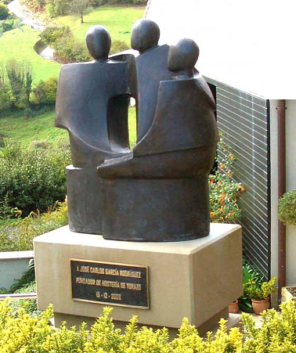

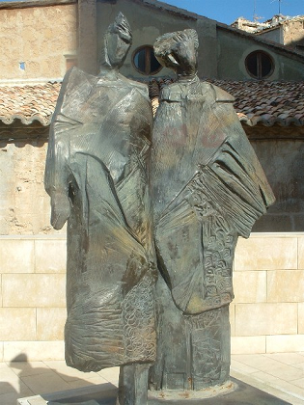

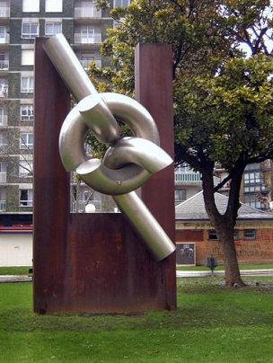

ALLEGORY OF FRIENDSHIP
ALEGORÍA A LA AMISTAD

Juan Miralles
Torazo (Asturias)

This allegory of friendship is represented by three people sitting and embracing to each other.

The sculpture is made of bronze.

FRIENDSHIP
LA AMISTAD

Robert Vandereycken,
2000 Alcañiz (Teruel) – Fraga (Huesca)
This Belgian artist donated a copy of the same sculpture to the towns of Alcañiz and Fraga to thanks them to have hosted his artworks’ exhibition.
Made of iron and bronze, according to the author, the sculpture simbolizes ‘friendship’ depicted by two people intertwined.

FRIENDSHIP
AMISTAD

José Noja

2003 Parque de Santurtzi, Santurtzi, Vizcaya.

According to the leaflet published by the Town Hall of Santurtzi: ‘the stainless steel links symbolize the union, embracing ideologies above discrepancies or religious beliefs, suggesting in its purity the values that give meaning to human existence, such as freedom, solidarity, justice and respect for diversity in plurality, with the hope of a better world for all human beings.

THE COMMUNICATION OF UNIVERSAL VALUES THROUGH MUSIC

NADIE COMO TÚ
LA OREJA DE VAN GOGH

Nadie como tu para hacerme reír.
Nadie como tu sabe tanto de mi
nadie como tu es capaz de compartir
mis penas, mi tristeza, mis ganas de vivir
tienes ese don de dar tranquilidad
de saber escuchar, de envolverme en paz.
Tienes la virtud de hacerme olvidar
el miedo que me da mirar la oscuridad.
Solamente tu lo puedes entender
y solamente tu te lo podrás creer.
En silencio y sin cruzar una palabra.
Solamente una mirada es suficiente para hablar
ya son mas de veinte años de momentos congelados
en recuerdos que jamás se olvidarán.
Nadie como tu para pedir perdón.
Nadie como tu valora esta canción.
Nadie como tu me da su protección,
me ayuda a caminar, me aparta del dolor.
tienes ese don de dar tranquilidad
de saber escuchar, de envolverme en paz.
Tienes la virtud de hacerme olvidar
el miedo que me da mirar la oscuridad.
Solamente tu lo puedes entender
y solamente tu te lo podrás creer.
En silencio y sin cruzar una palabra.
Solamente una mirada es suficiente para hablar
ya son mas de veinte años de momentos congelados
en recuerdos que jamás se olvidaran.
Y pasaran los años y siempre estarás buscando
un plan para que se hagan realidad los sueños
que soñábamos antes de ayer al dormir
hablando del tiempo que nos quedará por vivir.
Y sin hablar, sólo al mirar sabremos llegar a entender
que jamás ni nada ni nadie en la vida nos separará

NADIE COMO TÚ - LA OREJA DE VAN GOGH

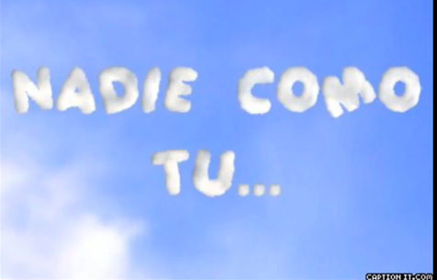
CLICK ON THE LINKS TO WATCH THE VIDEOS.

http://www.youtube.com/watch?v=_EMhDCI58zA

NO ONE LIKE YOU
LA OREJA DE VAN GOGH

No one like you to make me laugh.
No one like you knows so much about me
no one like you can share
my pain, my sadness, my will to live
you have the gift of giving me calm
You know how to listen to me and give me relief.

You have the virtue of making me forget
The fear I feel looking at the darkness.
Only you can understand it
And only you can believe it.

In silence and without saying a word.
A mere look is enough to talk
They are already more than twenty years
Of still moments
In good memories that we’ll never forget .

No one like you to ask forgiveness.
No one like you to appreciate this song.
No one like you to give me protection,
To help me to walk, to remove my pain.
you have the gift of giving me calm
You know how to listen to me and give me relief.

You have the virtue of making me forget
The fear I feel looking at the darkness.
Only you can understand it
And only you can believe it.

In silence and without saying a word.
A mere look is enough to talk
They are already more than twenty years
Of still moments
In good memories that we’ll never forget .
Years will pass and you’ll be always looking for
a plan to make your dreams come true,
those old dreams we had before sleeping
When we talked about our future time together

And without speaking, only looking at each other
We’ll understand
that never, nothing or nobody will split us.

NO ONE LIKE YOU - LA OREJA DE VAN GOGH

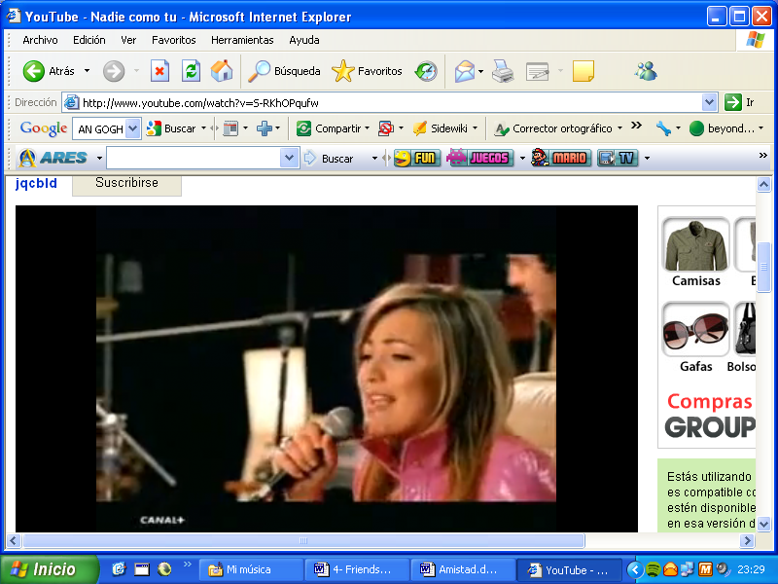

http://www.youtube.com/watch?v=S-RKhOPqufw

Laura Pausini, las cosas que vives

La Amistad Es Algo Que Atraviesa El Alma,
Es Un Sentimiento Que No Se Te Va.
No Te Digo Cómo, Pero Ocurre Justo
Cuando Dos Personas Van Volando Juntos.
Suben A Lo Alto Sobre La Otra Gente,
Como Dando Un Salto En La Inmensidad.
Y No Habrá Distancia No La Habrá
Ni Desconfianza, Si Te Quedas En Mi Corazón,
Ya Siempre.
Porque En Cada Sitio Que Estés,
Porque En Cada Sitio Que Esté,
En Las Cosas Que Vives, Yo También Viviré.
Porque En Cada Sitio Que Estés,
Nos Encontraremos Unidos
Uno En Brazos Del Otro, Es El Destino.
En La Misma Calle, Bajo El Mismo Cielo,
Aunque Todo Cambie No Nos Perderemos.
Abre Bien Los Brazos Mándame Un Aviso,
No Te Quepa Duda, Yo Te Encontraré.
No Estarás Ya Solo Yo Estaré
Continuando El Vuelo Que
Te Lleve Con Mi Corazón, Ya Siempre.
Porque En Cada Sitio Que Estés,
Porque En Cada Sitio Que Esté,
En Las Cosas Que Vives, Yo También Viviré.
Porque En Cada Sitio Que Estés,
No Nos Queda Más Que Un Camino,
Solo Habrá Dos Amigos, Tan Unidos.
Cree En Mí, No Te Atrevas A Dudar,
Todas Las Cosas Que Vives
Si Son Sinceras Como Tú, Y Yo,
Sabes Tu, Que Jamás Terminarán.
Porque En Cada Sitio Que Estés,
Porque En Cada Sitio Que Esté,
En Las Cosas Que Vives, Yo También Viviré.
Porque En Cada Sitio Que Estés, Que Estés,
Porque En Cada Sitio Que Esté, Y Que Esté.
Tú Me Llevas Contigo Dentro Del Corazón.
Porque En Cada Sitio Que Estés,
Nos Encontraremos Unidos,
Uno En Brazos Del Otro,
Es El Destino. Es El Destino.
Porque En Cada Sitio Que Estés,
Porque En Cada Sitio Que Esté,
En Las Cosas Que Vives, Yo También Viviré.

LAURA PAUSINI - LAS COSAS QUE VIVES
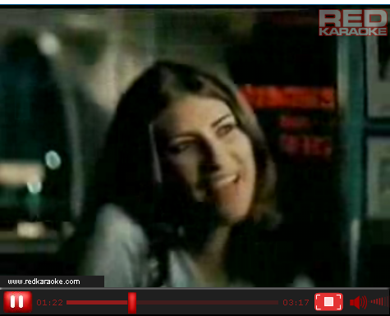
CLICK ON THE LINKS TO WATCH THE VIDEOS.
http://www.redkaraoke.es/videos/laura-pausini-las-cosas-que-vives/2579
LAURA PAUSINI, THE THINGS YOU LIVE
Friendship is something that pierces your soul,
It's an endless feeling.
I do not tell you how, but just occurs
When two people go flying together.
They feel to be high above the other people,
Like jumping in the immensity.
And there won’t be distance
Or distrust, if you stay in my heart,
For ever.
Because wherever you stay,
Because wherever I stay,
In the things you live, I’ll live too.
Because wherever you stay,
We will be close
One in the other's arms, It’s destiny.
On the same street, Under the same sky
Although everything changes we won’t get lost.
Open your arms, send me a sign,
You can be sure, I'll find you.
You no longer will be alone , I'll be there with you
Following the flight
Till you reach my heart, For ever.
Because wherever you stay,
Because wherever I stay,
In the things you live, I’ll live too.
Because wherever you stay,
We have no more than a way,
There will be only two close friends.
Trust in me, don’t dare to doubt,
All the things you are living
If they are sincere as you and me
You know, that never will end.
Because wherever you stay,
Because wherever I stay,
In the things you live, I’ll live too.
Because wherever you stay,
Because wherever I stay,
You take me into your heart.
Because wherever you stay,
We will be close,
One in the other's arms,
It’s destiny. It’s destiny.
Because wherever you stay,
Because wherever I stay,
In the things you live, I’ll live too.
LAURA PAUSINI - LAS COSAS QUE VIVES
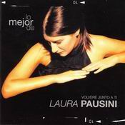
http://www.youtube.com/watch?v=Pscz2_w-i58

ACTITVITY 1: Complete the worksheet.

General features of friendship are: respect, sincerity, security, happiness, kindness, fairness, calm, trust, loyalty, generosity, love, disponibility, benevolence, esteem, concern, care, reciprocity, interaction, communication, closeness, consideration, support, forgiveness, help, solidarity, reliability, sharing, acceptance, patience, unconditional…

Write which of these features you appreciate in the followings paintings:

..........................................................................................................................................................
..........................................................................................................................................................
.......................................................................................................................................................................................................................................
..........................................................................................................................................................
.......................................................................................................................................................................................................................................

..........................................................................................................................................................
..........................................................................................................................................................
.......................................................................................................................................................................................................................................
..........................................................................................................................................................
.......................................................................................................................................................................................................................................

..........................................................................................................................................................
..........................................................................................................................................................
.......................................................................................................................................................................................................................................
..........................................................................................................................................................
.......................................................................................................................................................................................................................................

ACTITVITY 2

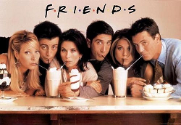

Pretend you are putting and ad in the paper to find a good friend.
List the qualities you are looking for and why. At the end of your
ad list the things they can expect from you if they respond to the
ad.

..............................................................................................................
..............................................................................................................
..............................................................................................................
..............................................................................................................
..............................................................................................................
..............................................................................................................
..............................................................................................................
..............................................................................................................
..............................................................................................................
..............................................................................................................
..............................................................................................................
..............................................................................................................
..............................................................................................................
..............................................................................................................
..............................................................................................................
..............................................................................................................
..............................................................................................................
..............................................................................................................
..............................................................................................................
..............................................................................................................
..............................................................................................................
..............................................................................................................
..............................................................................................................
..............................................................................................................
..............................................................................................................
..............................................................................................................

NAME.................................................................................

WANTED: FRIEND

ACTITVITY 3

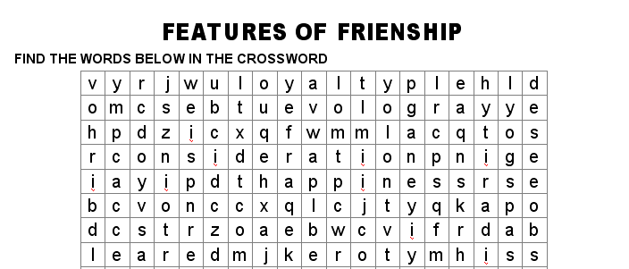

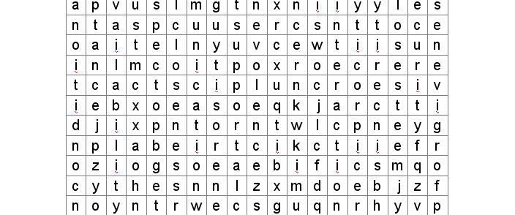

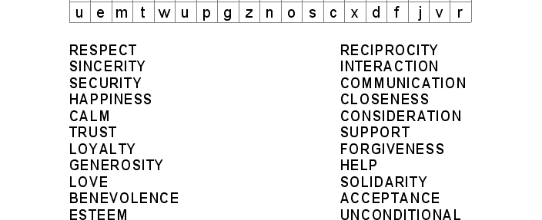

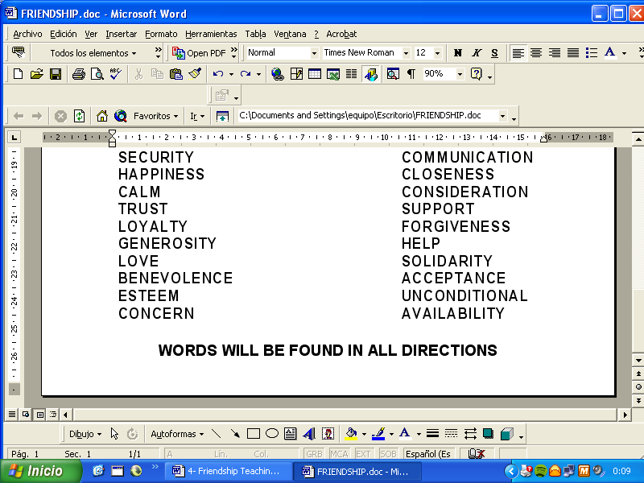

Words may be spelt horinzontally, vertically and backwards.
Circle each word as you find it.

FRIENDSHIP CROSSWORD SOLUTIONS

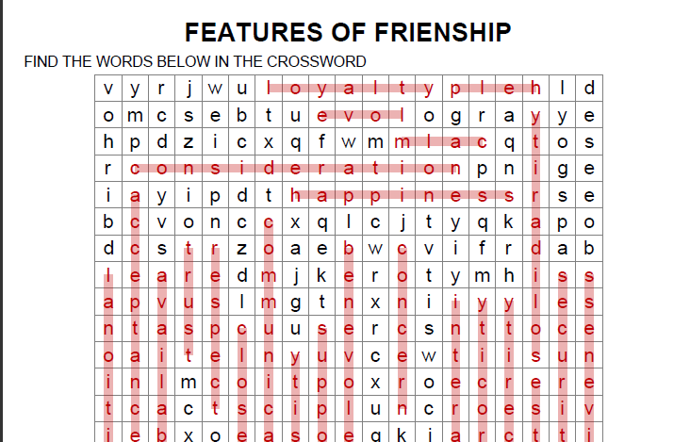
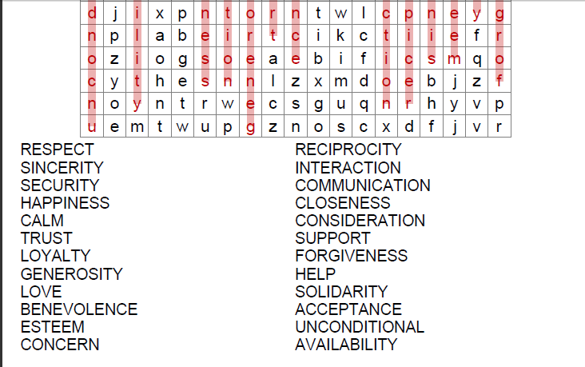

EXPLORING FRIENDSHIP


A PERSONAL INTERVIEW

Give short answers for these questions.

- What does someone make a friend?

- What do you expect from a friend?

- Why do you have the friends you have?

- What kind of things can you do together with your friends?

- How can friends be the same as you or different to you?

- What might make someone an enemy?

- What would be the benefits of having friends?

- How do you feel when you fall out with a friend?

- I am a good friend because

- The quality I appreciate most in a friend is

- Friendship goes wrong when

- When a friend lets me down I feel

- When a friend helps me I feel

- I could make a new friend by

WRITE ON EACH FINGER A QUALITY YOU CONSIDER THE MOST IMPORTANT IN FRIENDSHIP.

General features of friendship are:

respect, sincerity, security, happiness, kindness, fairness, calm, trust, loyalty, generosity, love, disponibility, benevolence, esteem, concern, care, reciprocity, interaction, communication, closeness, consideration, support, forgiveness, help, solidarity, reliability, sharing, acceptance, patience, unconditional…

The
most
important
qualities
in
friendship

Then the answers of the group should be evaluated, for example:
6 students think generosity is the most important quality in friendship.
9 students think sincerity is the most importan quality in friendship.
Etc…

