BEYOND WORDS

THE COMMUNICATION OF UNIVERSAL VALUES
THROUGH
THE LANGUAGE OF ART

TEACHING UNIT 6

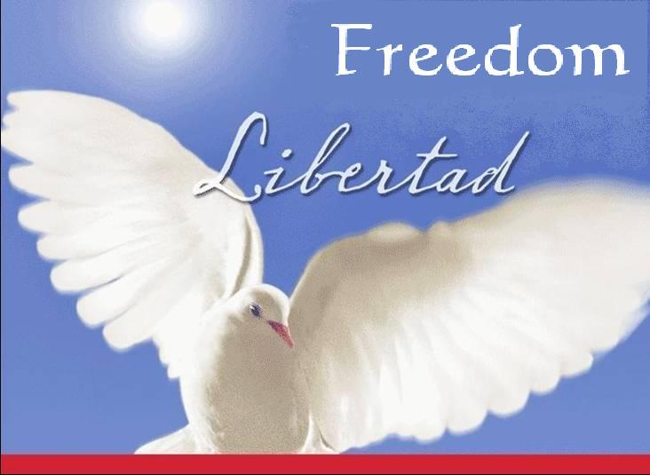

Liberty is the concept of ideological and political philosophy that identifies the condition to which an individual has the right to behave according to one's own personal responsibility and free will.

(From Wikipedia, the free encyclopedia)

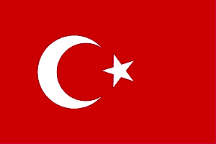

свобода vapaus ελευθερία libertá vrijheid libertate libertad özgürlük

THE COMMUNICATION OF UNIVERSAL VALUES THROUGH PAINTING

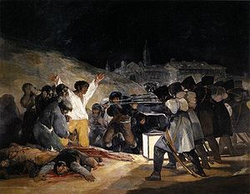

Click here for a larger view of the painting

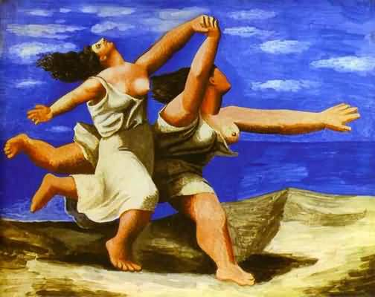

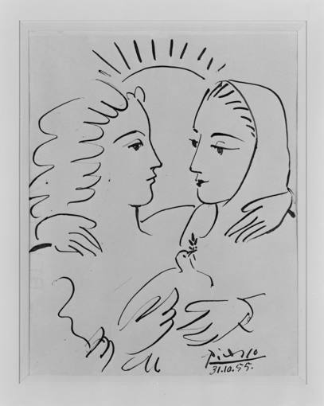

The shootings of May 3rd

LOS FUSILAMIENTOS DEL 2 DE MAYO

1814. Francisco de Goya
Museo del Prado. Madrid

In the painting, Goya sought to commemorate Spanish resistance to Napoleon's armies during the occupation of 1808 and the subsequent Spanish War of Independence of 1808–1814 to recover liberty.

WOMEN RUNNING ON THE BEACH

MUJERES CORRIENDO EN LA PLAYA

1922. Pablo Picasso
Museo Picasso. París

The Spanish painter depicts two women running together freely, hand in hand with the ocean in the background.

The painting transmit a sense o freedom. The two girls are running carefree, happy and bouncy.
The blue sky meets the blue sea highlighting the idea of no horizon, no limits… of freedom.

WOMEN WITH A DOVE
PAZ Y LIBERTAD

1955. Pablo Picasso
Collection Centre Pompidou

This painting ‘Women with dove’ depicts an embrace between two women representing peace and freedom.
The rising sun in the background suggests hope in the future.

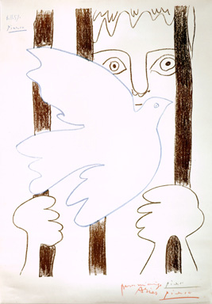

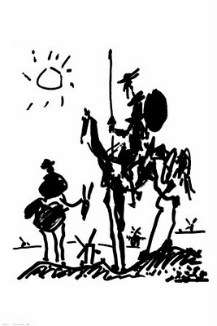

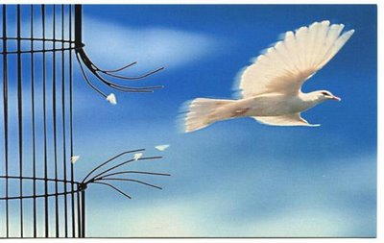

THE PRISONER AND THE DOVE
PRESO CON PALOMA DE LA PAZ

1959. Pablo Picasso.
Museo Picasso - Colección Eugenio Arias.
Buitrago del Lozoya – Madrid

Bars and Birds: Prison and Freedom.
The painting depicts a prisoner behind bars and a dove flying in front of him.
Picasso uses this symbolism to represent freedom.ot

This image has been used by non governmental organization Amnesty International as an icon to claim freedom for political prisoners.

DON QUIXOTE / DON QUIJOTE

1955. Pablo Picasso.
The original painting is lost.

The drawing was made to celebrate the 350th anniversary of the publication of Don Quixote Part 1, and it originally appeared in the August 18-24 issue of ‘Les lettres françaises’, a weekly French journal.

Don Quixote and Sancho stand out against a white background. There is a sun in the corner and windmills everywhere. Don Quixote appears thin on his horse Rocinante which is as thin as its owner.

In one ocassion Don Quixote tells Sancho Panza:

"Freedom, Sancho, is one of the most precious gifts given to man by heaven. Freedom is the most valuable treasure on the earth and under the sea.
For it , and also for honour, one’s life may and must be put in danger”.



THE COMMUNICATION OF UNIVERSAL VALUES THROUGH SCULPTURE

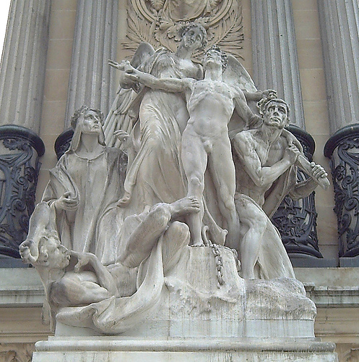

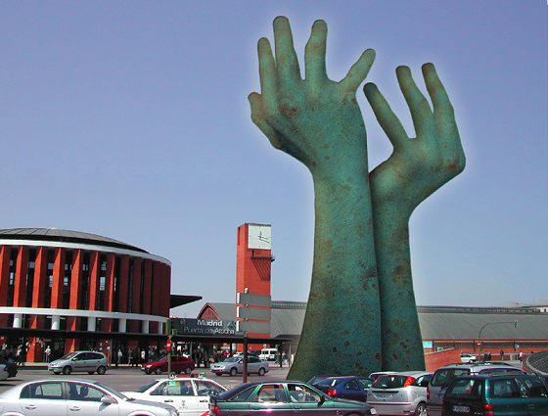

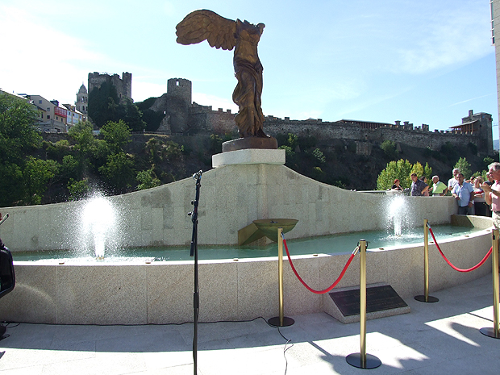

MEMORIAL TO FREEDOM
LA LIBERTAD

1904. Aniceto Marinas García
Parque del Retiro. Madrid

Liberty. Allegoric sculptural group made of limestone by Aniceto Marinas García (1866–1953). Detail of the Monument to king Alfonso XII of Spain in the Retiro Park in Madrid (Spain), built from 1902 to 1922. Liberty is represented by the winged young lady (center), accompanied by The Literature (left) while she frees three condemned, symbolizing thus a double liberty, both material and spiritual.

MEMORIAL TO VICTIMS OF TERRORISM
MONUMENTO A LAS VÍCTIMAS DEL TERRORISMO

Atocha Station. Madrid

On 11th March 2004 a terrible terrorist attack killed 191 people and injured 1858 more. It was the biggest attack against liberty in Europe.

The Madrid train bombings consisted of a series of coordinated bombings against the Cercanías (commuter train) system of Madrid, Spain on the morning of 11 March 2004 (three days before Spain's general elections).

The two hands raised to heaven symbolise a tree split by pain claiming freedom and peace.

MEMORIAL TO FREEDOM

MONUMENTO A LAS VÍCTIMAS DE LA REPRESIÓN

2009. Ponferrada. León

This reproduction in broze of the Greek statue of the Victory of Samothrace was erected to commemorate the victims for freedom and to claim that tolerance, dialogue, respect and dignity of human life prevail for ever.

THE COMMUNICATION OF UNIVERSAL VALUES THROUGH MUSIC

LIBERTAD SIN IRA

Dicen los viejos que en este país hubo
una guerra
y hay dos Españas que guardan aún,
el rencor de viejas deudas.
Dicen los viejos que este país necesita
palo largo y mano dura
para evitar lo peor.
Pero yo sólo he visto gente
que sufre y calla,
dolor y miedo.
Gente que sólo desea su pan,
su hembra y la fiesta en paz
Libertad, libertad sin ira libertad
guárdate tu miedo y tu ira
porque hay libertad, sin ira libertad
y si no la hay sin duda la habrá.
Libertad, libertad sin ira libertad,
guárdate tu miedo y tu ira
porque hay libertad, sin ira libertad
y si no la hay sin duda la habrá.
Dicen los viejos que hacemos lo que nos da la gana
y no es posible que así pueda haber
Gobierno que gobierne nada.
Dicen los viejos que no se nos dé rienda suelta,
que todos aquí llevamos
la violencia a flor de piel.
Pero yo sólo he visto gente muy obediente
hasta en la cama.
Gente que tan sólo pide
vivir su vida, sin más mentiras y en paz
Libertad, libertad sin ira libertad,
guárdate tu miedo y tu ira
porque hay libertad, sin ira libertad
y si no la hay sin duda la habrá.
Libertad, libertad sin ira libertad,
guárdate tu miedo y tu ira
porque hay libertad, sin ira libertad
y si no la hay sin duda la habrá

ANABEL DUEÑAS - LIBERTAD SIN IRA

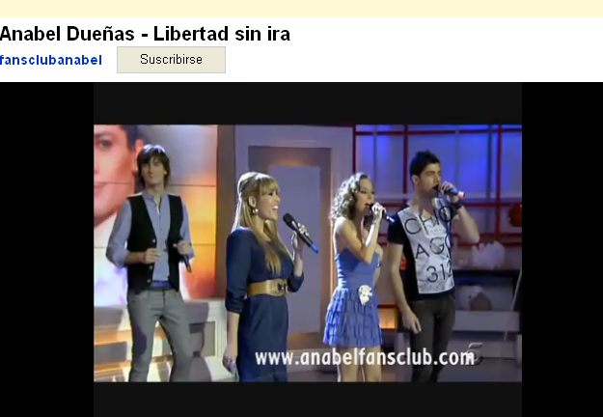
http://www.youtube.com/watch?v=pUcmOWVPnCs

FREEDOM WITHOUT ANGER

Old people say that in this country
there was a war
and that there are two Spains still
keeping the resentment of old debts.
They also say that this country needs
discipline and iron fist
to avoid the worst.
But I've only seen people
suffering silently
their grief and fear.
People who just want to earn their living,
to have a partner and a quiet life.
Freedom, freedom without anger
forget your fear and anger
because there is freedom, freedom without anger
and if there isn’t freedom yet, for sure there will be.
Freedom, freedom without anger
forget your fear and anger
because there is freedom, freedom without anger
and if there isn’t freedom yet, for sure there will be.
Old people say that we do whatever we want
and so is no possible
to be ruled by any Government.
They also say that we need to be under control
because all of us are violent
by nature.
But I have only seen very obedient people
even in their private affairs.
People who only want
to live their life, no more lies and peace.
Freedom, freedom without anger,
forget your fear and anger
because there is freedom, freedom without anger
and if there isn’t freedom yet, for sure there will be.
Freedom, freedom without anger,
forget your fear and anger
because there is freedom, freedom without anger
and if there isn’t freedom yet, for sure there will be.

JARCHA - LIBERTAD SIN IRA

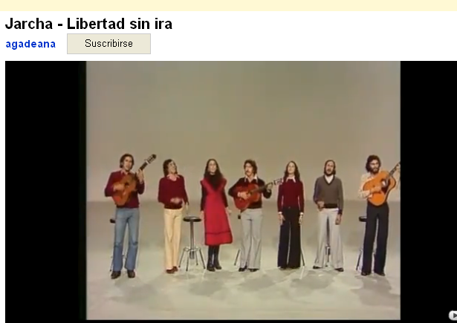

http://www.youtube.com/watch?v=tW8IuOukCI8

CANTO A LA LIBERTAD

Habrá un día en que todos
Al levantar la vista
Veremos una tierra
Que ponga libertad (bis)
Hermano aquí mi mano
Será tuya mi frente
Y tu gesto de siempre
Caerá sin levantar
Huracanes de miedo
Ante la libertad
Haremos el camino
En un mismo trazado
Uniendo nuestros hombros
Para así levantar
A aquellos que cayeron
Gritando libertad
Sonarán las campanas
Desde los campanarios
Y los campos desiertos
Volverán a granar
Unas espigas altas
Dispuestas para el pan
Para un pan que en los siglos
Nunca fue repartido
Entre todos aquellos
Que hicieron lo posible
Para empujar la historia
Hacia la libertad
También será posible
Que esa hermosa mañana
Ni tú, ni yo, ni el otro
La lleguemos a ver
Pero habrá que empujarla
Para que pueda ser
Que sea como un viento
Que arranque los matojos
Surgiendo la verdad
Y limpie los caminos
De siglos de destrozos
Contra la libertad

LABORDETA - CANTO A LA LIBERTAD

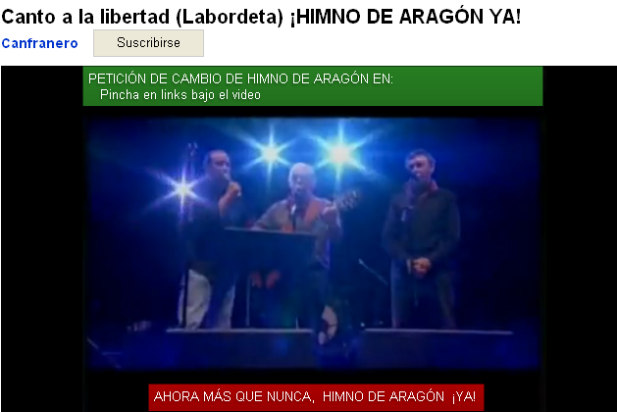
http://www.youtube.com/watch?v=i15eFc_BCu4

A SON FOR FREEDOM

There will be a day when all of us
Looking up
Will see a land
Where to live in freedom (repeat)
Brother here is my hand
My heart is with you
We will live
Our lives
Without hurricanes of fear
Because there is freedom
We will make the same way
Walking side by side
Joining our shoulders
to raise
Those who died
Claiming Freedom
Bells will ring
From the bell towers
And in the wild fields
Tall wheat ears
Will grow again
Ready to make bread
Bread that in the past
Never was given
To those
Who did their best
To push the story
To reach Freedom
It will also be possible
That such a beautiful morning
Neither you or I, nor the others
Could enjoy Freedom
But we must work
In order to get it.
Our sacrifices will be the wind
That pull the weeds up
Giving place to Truth
And cleaning the roads
After so many centuries fighting
Against Freedom.

CHINA CHANA - CANTO A LA LIBERTAD

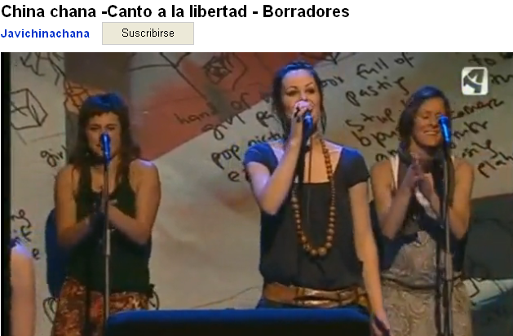
http://www.youtube.com/watch?v=4oOpbGM8fnw

ACTIVITY 1

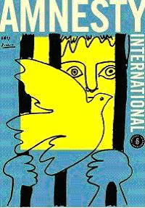

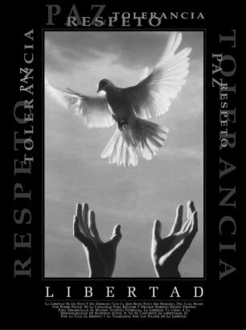

This poster is a reproduction of the painting ‘THE PRISONER AND THE DOVE’ by Pablo Picasso.

What does this image suggest to you?

……………………………………………………………………………………………………………………………………………………………………………………………………………………………………………………
………………………………………………………………………………………………………………………………………………………………………………………
……………………………………………………………

Why do you think to have been chosen by AMNESTY INTERNATIONAL?

……………………………………………………………………………………………………………………………………………………………………………………………………………………………………………………
……………………………………………………………………………………………………………………………………………………………………………………………………………………………………………………

The title of this poster is LIBERTAD (FREEDOM)
There are other values on the picture: respect, tolerance and peace.
Do you think these values are connected with freedom.
…………………………………………………………….

Why?

……………………………………………………………………………………………………………………………………………………………………………………………………………………………………………………
……………………………………………………………………………………………………………………………………………………………………………………………………………………………………………………
…………………………………………………………………………………………………………………………………………………………………………………………………………………………………………………….

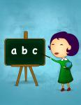 | ACTIVIY 2 The Experiments of Miss Ellis  Educational Value  Freedom  Moral of the story  Three short examples to demonstrate essential aspects of freedom

Story

That weekend Miss Ellis handed out another of her famous experiment assignments. Her pupils loved that form of teaching, in which they themselves had to think up experiments that would aid in understanding. Many had to do with science, chemistry, but others - the most famous experiments - had to do with people and their behaviour. And on that occasion the subject was really difficult: freedom. How can one conduct an experiment on freedom? What could you show about freedom through experiments?

On their way home, the students discussed these, and other similar questions. However, they had already done a good job on other experiments, and this time was no exception. On Monday, the students returned with their ideas for an experiment, and they explained them one by one. All the ideas were very interesting but, to cut a long story short, Miss Ellis has asked me to tell you only about Amanda, Charlie, and Andrea's experiments - which she liked the most.

Amanda took out five different coloured boxes and gave them to the teacher to choose one. Miss Ellis gratefully took the pink box, and smiled. Then Amanda took out five yellow boxes, and asked Charlie to choose one. Charlie, annoyed, carelessly chose one. Miss Ellis, amused, asked Amanda what the experiment was called.

"I've called it 'Choices'." For freedom to exist you have to choose between different options. That's why Charlie was a bit annoyed, because when the boxes are all the same colour, you are not really allowed to choose. But Miss Ellis has been pleased because she got to choose the box she liked the most".

Charlie had prepared another kind of experiment, a more lively one. He chose two class members. Lucas was a bright but indecisive boy, and Paul was one of the worst students. Charlie made them go up to join Miss Ellis at the blackboard. Then he divided the class into three groups.

To the first group he said: "I'm going to ask you a difficult question. You can choose one of the three people at the blackboard to help you answer it. Whoever gets the answer right will win a big bag of sweets". Everyone in the first group chose the teacher.

Then Charlie said to the second group: "You will be asked the same question, but before we start you should know that I have given Paul a piece of paper with the question and its answer written on it". Amid the sound of complaints from the first group, the second group all chose Paul.

Then Charlie spoke to the last group: "It's your turn. What I told the second group was a lie. I gave the paper to Lucas". Amid booing and a few laughs, Paul showed that his hands were empty, and Lucas showed everyone that he did indeed have a piece of paper with the question and answer on it. And Lucas was the only one who managed to answer the difficult question correctly.

While the winners were sharing the sweets out to everyone, Charlie explained: "This experiment is called 'No Freedom Without Truth' "It shows that you can only choose freely if you know the whole truth of the situation. Groups one and two were free to choose who they wanted, but as they didn't know the full truth of the set-up, they were not really choosing freely. If they had known, then they would have chosen differently.

Andrea's experiment was very different. She had come to class with Laylow, her hamster, and some pieces of cheese and bread, to prepare a few different tests. In the first she covered a piece of cheese with a glass. And at its side she placed a piece of bread, without covering it. When she set Laylow free, the hamster went straight for the cheese, banging his nose against the glass. Laylow tried to get to the cheese for a good old while, but having no success he settled for the bread.

Andrea carried on with some similar experiments, a little cruel, but amusing, in which poor Laylow could never get to the cheese and had to choose the bread. Finally, Andrea put a lump of cheese and a lump of bread on the table, both uncovered. This time, Laylow, bored, went straight over and ate the bread.
Everyone enjoyed the experiment, and while Miss Ellis rewarded Laylow with the cheese, Andrea explained: "The experiment is called 'Limits'. It shows that, whether we know it or not, our freedom always has limits, and that these limits are not always outside ourselves. They can be inside us too, as with Laylow, who thought he would never be able to get the cheese.

Many more interesting experiments were performed that day, and maybe sometime we'll get to talk about them, but what is clear is that Miss Ellis' students ended up knowing a lot more about freedom than do many much older people.

Author. Pedro Pablo Sacristan
Source URL: http://freestoriesforkids.com/children/stories-and-tales/experiments-miss-ellis
WORKSHEET - The Experiments of Miss Ellis
The moral of the story is to demonstrate three essential aspects of freedom:
Choices - No Freedom Without Truth - Limits

After reading the story carefully, please answer these questions:

1.- Rewrite the words of the story explaining the word ‘Choices’.

…………………………………………………………………………………………………………………………………….

…………………………………………………………………………………………………………………………………….

2.- Rewrite the words of the story making reference to ‘No Freedom Without Truth’.

…………………………………………………………………………………………………………………………………….

…………………………………………………………………………………………………………………………………….

3.- Rewrite the words of the story defining the word ‘Limits’.

……………………………………………………………………………………………………………………………………

……………………………………………………………………………………………………………………………………

4.- Do you agree that Choices - No Freedom Without Truth - Limits are essentials aspects of freedom? Why?

…………………………………………………………………………………………………………………………………….

…………………………………………………………………………………………………………………………………….

…………………………………………………………………………………………………………………………………….

…………………………………………………………………………………………………………………………………….

5.- Can you list some more aspects of freedom?

…………………………………………………………………………………………………………………………………….

…………………………………………………………………………………………………………………………………….

6.- Can you explain the last words of the story ‘Miss Ellis' students ended up knowing a lot more about freedom than do many much older people’?

…………………………………………………………………………………………………………………………………….

…………………………………………………………………………………………………………………………………….

…………………………………………………………………………………………………………………………………….

7.- Make a personal comment about this story.

…………………………………………………………………………………………………………………………………….

…………………………………………………………………………………………………………………………………….

…………………………………………………………………………………………………………………………………….

…………………………………………………………………………………………………………………………………….

ACTIVIDAD 2 Los experimentos de la señorita Elisa

Valor Educativo

La libertad

Idea y enseñanza principal
Tres breves ejemplos para comprender aspectos esenciales de la libertad

Cuento

La señorita Elisa aquel fin de semana les propuso uno de sus famosos trabajos sobre experimentos. A sus alumnos les encantaba aquella forma de enseñar, en la que ellos mismos tenían que pensar experimentos que ayudaran a comprender las cosas. Muchos tenían que ver con las ciencias o la química, pero otros, los que más famosa la habían hecho, tenían que ver con las personas y sus comportamientos. Y aquella vez el tema era realmente difícil: la libertad. ¿Cómo puede hacerse un experimento sobre la libertad? ¿Qué se podría enseñar sobre la libertad a través de experimentos?
Estas y otras preguntas parecidas se hacían los alumnos camino de sus casas. Pero ya se habían lucido con otros experimentos difíciles, y aquella vez no fue una excepción. El lunes llegaron con sus experimentos listos, y fueron mostrándolos uno a uno. Fueron muy interesantes, pero para no hacer muy larga la historia, la señorita Elisa me ha pedido que sólo cuente los experimentos de Amaya, Carlos y Andrea, que le gustaron mucho.

Amaya llevó 5 cajas de colores y le dio a elegir a la profesora. La maestra, agradecida, escogió la caja rosa con una sonrisa. Luego Amaya sacó 5 cajas amarillas, se acercó a Carlos y le dio a elegir. Carlos contrariado, tomó una cualquiera. La señorita Elisa, divertida, preguntó a Amaya cómo se llamaba el experimento.

Lo he titulado "Opciones". Para que exista libertad hay que elegir entre distintas opciones. Por eso Carlos se ha enfadado un poco, porque al ser las cajas iguales realmente no le he dejado elegir. Sin embargo la señorita Elisa estaba muy contenta porque pudo elegir la caja que más le gustó.

Carlos había preparado otro tipo de ejercicio más movido: hizo subir a la pizarra a la maestra, a Lucas, un chico listo pero vaguete, y a Pablo, uno de los peores de la clase. Entonces, dividió la clase en tres grupos y dijo dirigiéndose al primer grupo: Voy a haceros una pregunta dificilísima; podéis elegir a cualquiera de los tres de la pizarra para que os ayude a contestarla. Quien acierte se llevará una gran bolsa de golosinas. Todos eligieron a la maestra. Entonces Carlos dijo a los del segundo grupo: La misma pregunta va a ser para vosotros, pero tenéis que saber que a Pablo, antes de empezar, le he dado un papel con la pregunta y la respuesta. Entre las quejas de los del primer grupo, los del segundo eligieron sonrientes a Pablo.

Luego Carlos siguió con los últimos: Os toca a vosotros. Lo que les he contado a los del segundo grupo era mentira. El papel se lo había dado a Lucas. Y entre abucheos de unos y risas de otros, Pablo mostró las manos vacías y Lucas enseñó el papel con la pregunta y la respuesta. Por supuesto, fue el único que acertó la difícil pregunta que ni la maestra ni Pablo supieron responder.

Mientras los ganadores repartían las golosinas entre todos, Carlos explicó: Este experimento se llama "Sin verdad no hay libertad". Demuestra que sólo podemos elegir libremente si conocemos toda la verdad y tenemos toda la información. Los grupos 1 y 2 parecía que eran libres para elegir a quien quisieran, pero al no saber la verdad, realmente no eran libres, aun sin saberlo, cuando eligieron. Si lo hubieran sabido su elección habría sido otra

El experimento de Andrea fue muy diferente. Apareció en la clase con Lalo, su hámster, y unos trozos de queso y pan, y preparó distintas pruebas. En la primera puso un trozo de queso, cubierto con un vaso de cristal, y al lado un pedazo de pan al aire libre. Cuando soltó a Lalo, este fue directo al queso, golpeándose contra el vaso. Trató de llegar al queso durante un buen rato, pero al no conseguirlo, terminó comiendo el pan. Andrea siguió haciendo pruebas parecidas durante un rato, un pelín crueles, pero muy divertidas, en las que el pobre Lalo no podía alcanzar el queso y terminaba comiendo su pan.

Finalmente, colocó un trozo de queso y otro pan, ambos sueltos, y Lalo, aburrido, ignoró el queso y fue directamente a comer el pan. El experimento gustó mucho a todos, y mientras la señorita Elisa premiaba a Lalo con el queso que tanto se había merecido, Andrea explicó: El experimento se llama "Límites". Demuestra que, lo sepamos o no, nuestra libertad siempre tiene límites, y que no sólo pueden estar fuera, sino dentro de nosotros, como con mi querido Lalo, que pensaba que no sería capaz de coger el queso aunque estuviera suelto.

Muchos más experimentos interesantes se vieron ese día, y puede que alguna vez los contemos, pero lo que está claro es que los niños de la clase de la señorita Elisa terminaron sabiendo de la libertad más que muchos mayores.
Autor.. Pedro Pablo Sacristan

URL original: http://cuentosparadormir.com/infantiles/cuento/los-experimentos-de-la-senorita-elisa

FICHA ACTIVIDAD 2 - LOS EXPERIMENTOS DE LA SEÑORITA ELISA
La enseñanza del cuento es mostrar tres aspectos esenciales de la libertad:
Opciones – Sin verdad no hay libertad - Límites
Después de leer atentamente la historia, contesta las siguientes preguntas:

1.- Copia las palabras del cuento que explican la palabra ‘Opciones’.

…………………………………………………………………………………………………………………………………….

…………………………………………………………………………………………………………………………………….

2.- Copia las palabras de la historia que hacen referencia a la afirmación ‘Sin verdad no hay libertad’.

…………………………………………………………………………………………………………………………………….

…………………………………………………………………………………………………………………………………….

3.- Copia las palabras del cuento que definen la palabra ‘Límites’.

……………………………………………………………………………………………………………………………………

……………………………………………………………………………………………………………………………………

4.- ¿Crees tú que Opciones – Sin verdad no hay libertad – Límites son aspectos fundamentales de la libertad? ¿Por qué?

…………………………………………………………………………………………………………………………………….

…………………………………………………………………………………………………………………………………….

…………………………………………………………………………………………………………………………………….

…………………………………………………………………………………………………………………………………….

5.- ¿Podrías enumerar más aspectos de la libertad?

…………………………………………………………………………………………………………………………………….

…………………………………………………………………………………………………………………………………….

6.- ¿Qué crees tú que significa la afirmación al final de la historia ‘los niños de la clase de la señorita Elisa terminaron sabiendo de la libertad más que muchos mayores’.

…………………………………………………………………………………………………………………………………….

…………………………………………………………………………………………………………………………………….

…………………………………………………………………………………………………………………………………….

7.- Haz un breve comentario personal sobre esta historia.

…………………………………………………………………………………………………………………………………….

…………………………………………………………………………………………………………………………………….

…………………………………………………………………………………………………………………………………….

…………………………………………………………………………………………………………………………………….

